The William & Mary Herbarium (WILLI)

The Herbarium of the College of William & Mary was founded in 1969 and has since grown to house over 77,000 plant specimens. The herbarium ranks third largest in the state and houses one of the largest collections of Virginia coastal plain flora. Students and their projects have contributed over one half of its current holdings.

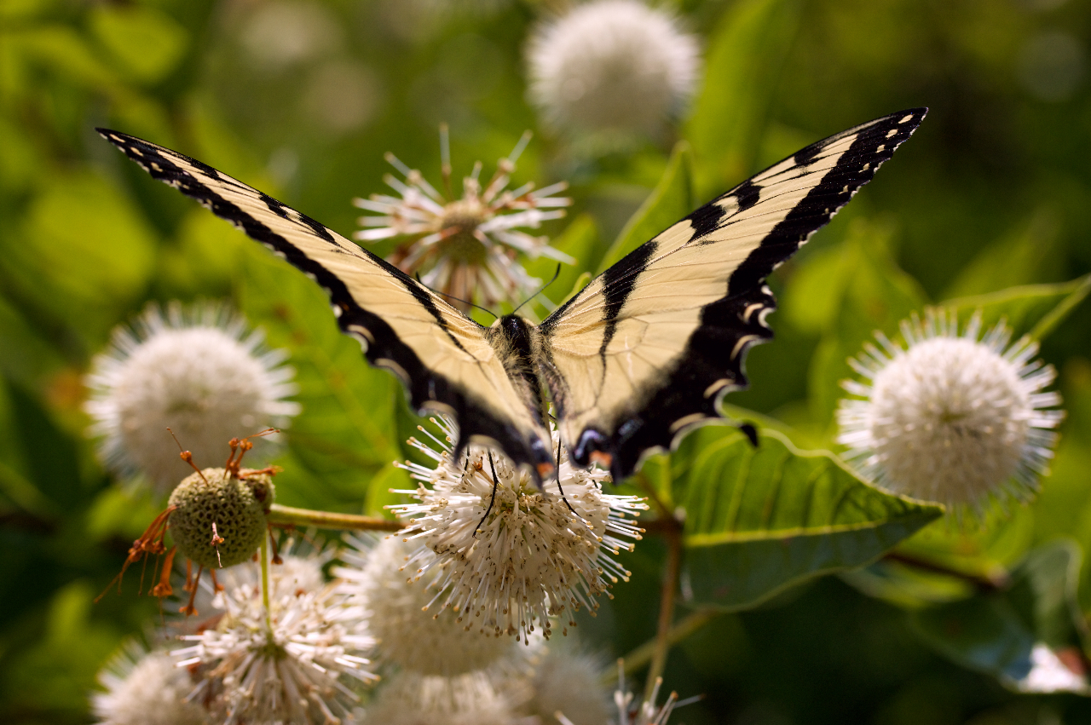
Virginia buttonbush and swallow-tail
Photo by Pablo Yanez

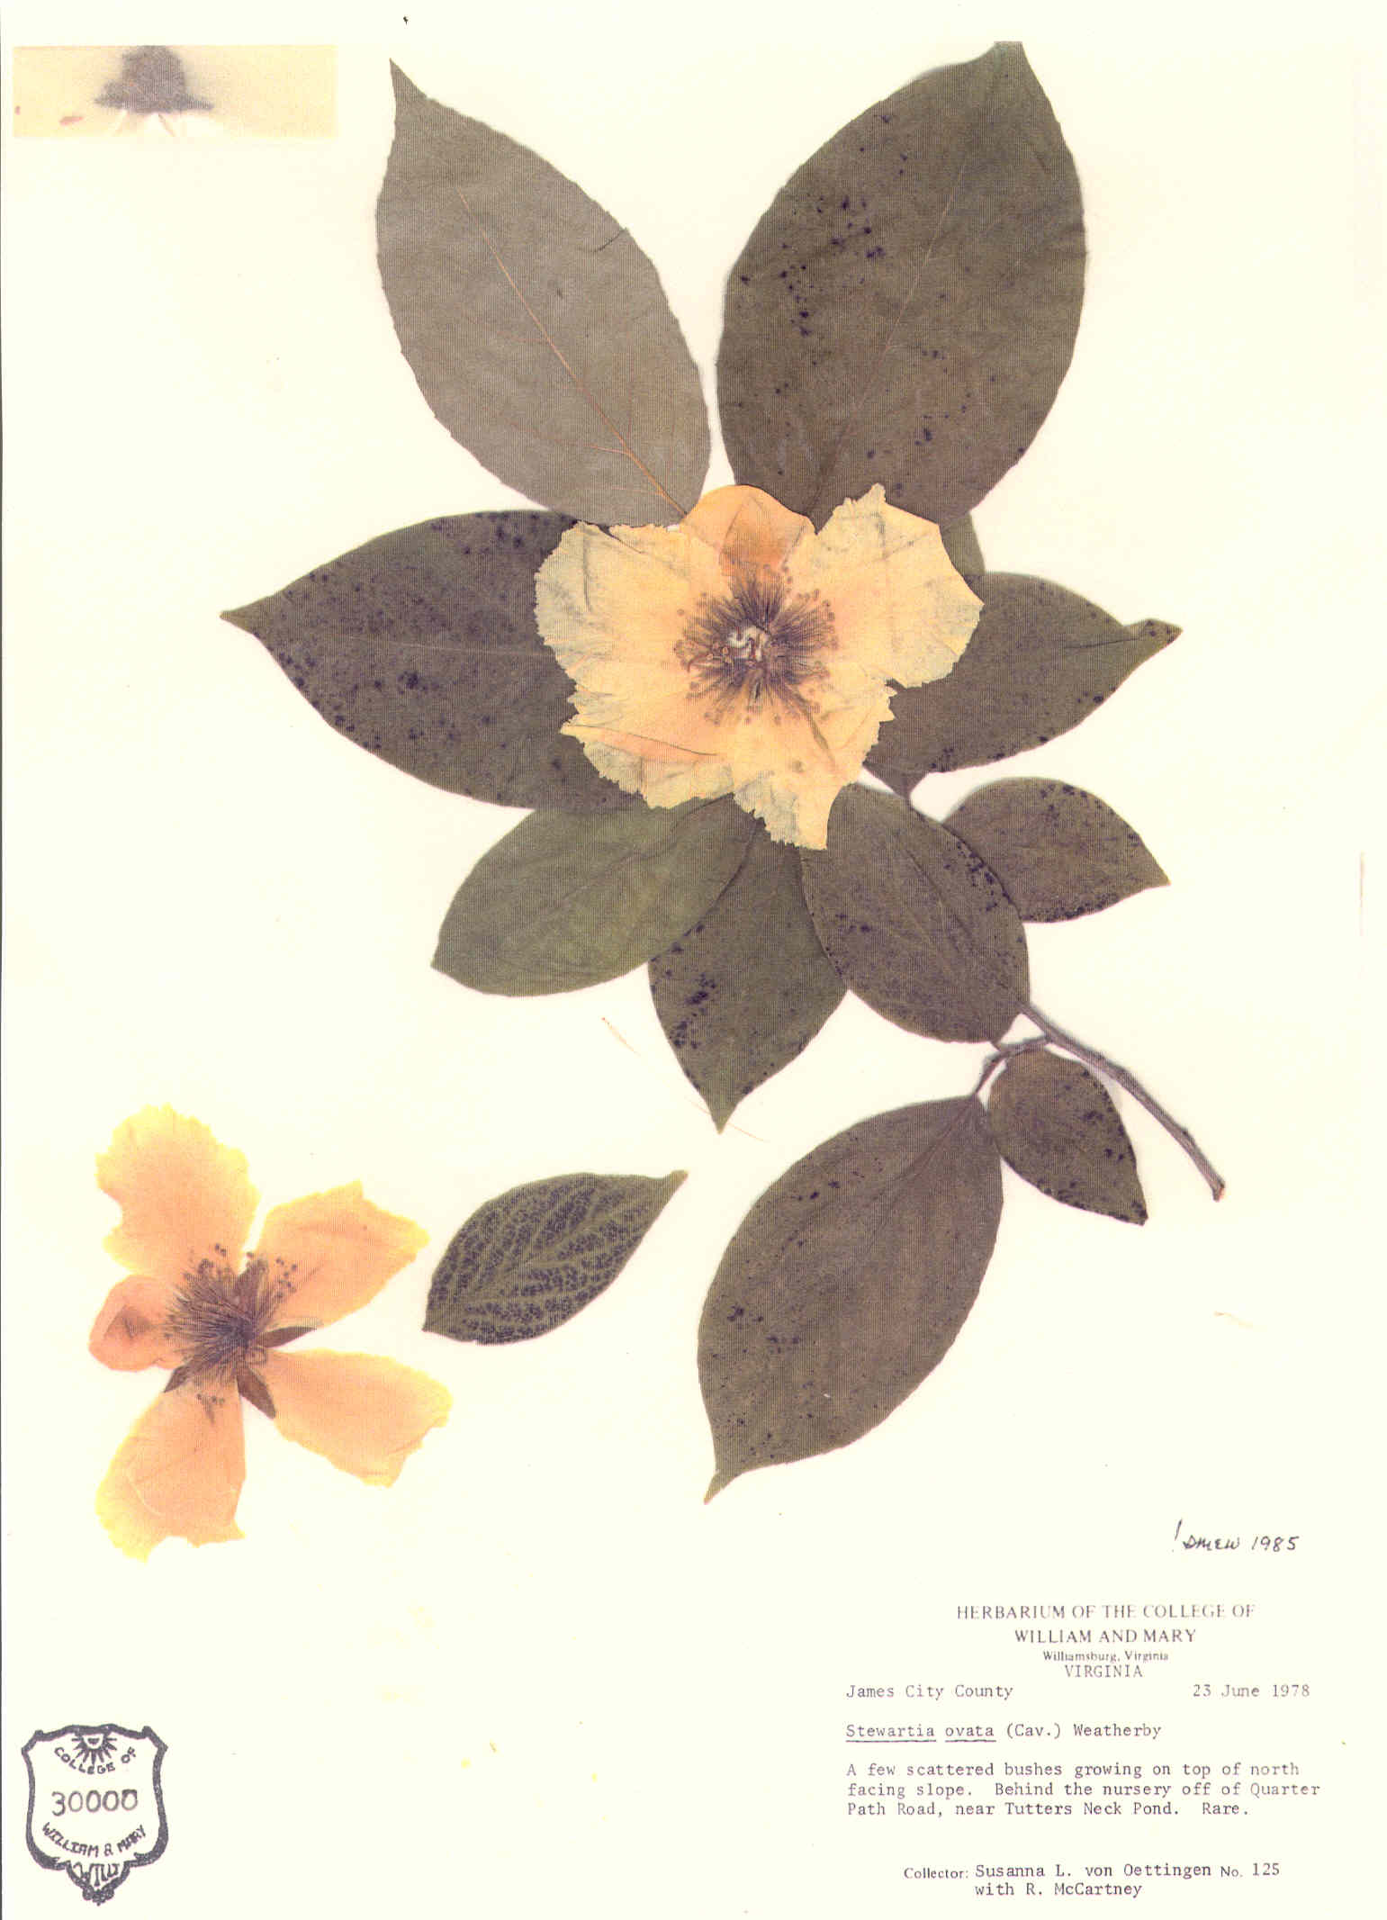
Herbaria

A herbarium is a library of dried, pressed, and mounted plant specimens.
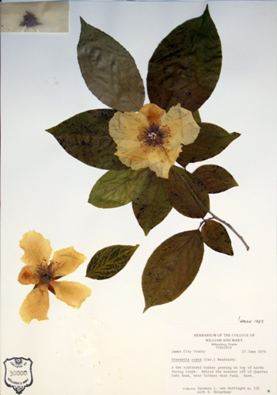

A herbarium specimen and its label.
- By including a collector’s label, herbarium specimens document where and when a particular plant grew.
- Herbarium specimens can be used to understand species’ identifying features, geographic ranges, specific ecologies, and natural patterns of variation present in the wild.

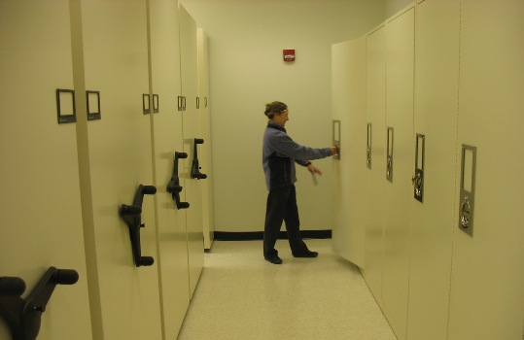

A portion of the herbarium with its director, Dr. Martha Case.

- At William & Mary over 50 cases hold the collection in a climate-controlled environment. This facility was supported, in part, by a grant from the National Science Foundation.
- The herbarium is part of an international network of plant researchers who may visit, borrow and exchange specimens for study.
- Research projects from herbarium students and their faculty mentors appear in over 50 publications.

Community involvement

A herbarium greatly benefits the local community.

- Herbaria staff and associates frequently volunteer their time and expertise to the public which includes plant identifications, campus plant tours, and general information about regional plants and their environments.

  - Community and student involvement are vital to the function of the William & Mary Herbarium. Projects include:
-Database management
-Specimen collection and other research projects
-Specimen processing

Your donations support outreach service, student training and ongoing research

- To donate to the herbarium, make your check payable to:

College of William & Mary Foundation

- In your check’s memo area, write:

Biology (2860) Herbarium

- Send your check to:

Dr. Liz Allison, Chair
Biology Department
P.O. Box 8795
College of William & Mary
Williamsburg, VA 23187

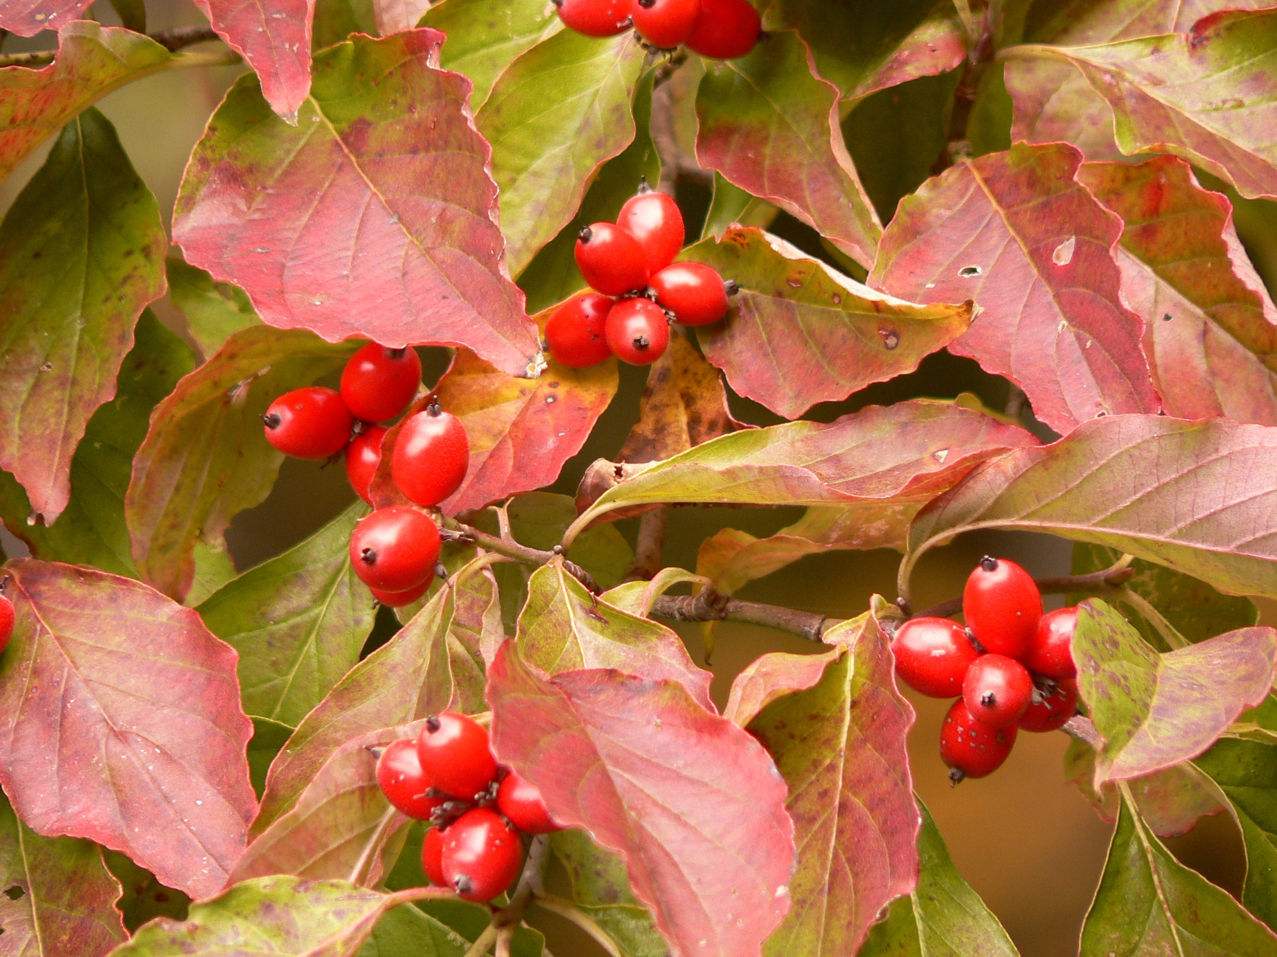

Thank you for your support!

Dr. Liz A. Allison
Chair, Biology Department

Dr. Martha A. Case
Director, William & Mary Herbarium

Ms. Beth H. Chambers
Curator of the Herbarium
757-221-2213
willi@wm.edu
http://www.wm.edu/herbarium

