Please visit our website:
www.wm.edu/globalstudies

Special thanks to the organizing committee:

Anita Angelone, Modern Languages and Literatures
Tuska Benes, History
Gail Bossenga, History
Bruce Campbell, Modern Languages and Literatures
Fred Corney, History
Gregor Kranjc, History
Kathrin Levitan, History
Giulia Pacini, Modern Languages and Literatures
Paula Pickering, Government
Carl Strikwerda, History

Minority Urban
Cultures

Sixth Annual Student-Faculty Conference in European Studies

April 1-2, 2011

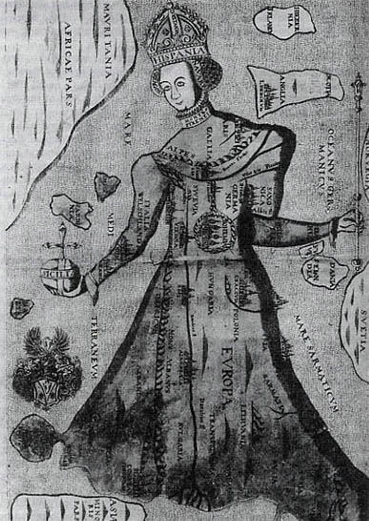

Sponsored by European Studies, the Charles Center and the Wendy and Emery Reves Center for
International Studies

Friday, April 1

Keynote speaker: 4:00 pm, Washington 201

"What Made a Home Jewish? Ruminations on Material Culture and Embodiment in Interwar Paris and Berlin"

Leora Auslander, Professor of History, University of Chicago.

.

The European Studies
program at W&M is pleased
to present this student-faculty conference.

All events are free and open to
the public.

Saturday, April 2

Student Panels
Blow Hall 331

8:00 - 8:30: BREAKFAST

8:30 - 10:30: State Interventions

Liz Forro, “”

Pam Snyder, “The Relationship between the Russian Federation and the Russian Diaspora in the Near Abroad”

Jennifer Stolz, "Language Policy and Tatars in the Soviet Union and the Russian Federation"

Anca Cretu, “Identity Reflections in Modern Romania: An Analysis of Minority Policies from Unification to Accession (1918-2007)”

10:45 - 12:45: Culture and Identity

Rhode N’komba “Spain and Romani: a History of Love-Hate Coexistence”

Monika Bernotas, “Exploring the Written Memories of Lithuanian Women in Siberia”

Maggie Reeb, “”

Emily Sample, "Visual Representations of the Holocaust in Memorials in the Czech Republic and United States."

12:30 - 1:30: LUNCH and CLOSING REMARKS

