Please visit our website:
www.wm.edu/globalstudies

Special thanks to the organizing committee:

Anita Angelone, Modern Languages and Literatures
Tuska Benes, History
Rob Leventhal, Modern Languages and Literatures
Kathrin Levitan, History
Giulia Pacini, Modern Languages and Literatures
Leslie Waters, History

European
Borderlands

Seventh Annual Student-Faculty Conference in European Studies

April 13-14, 2012

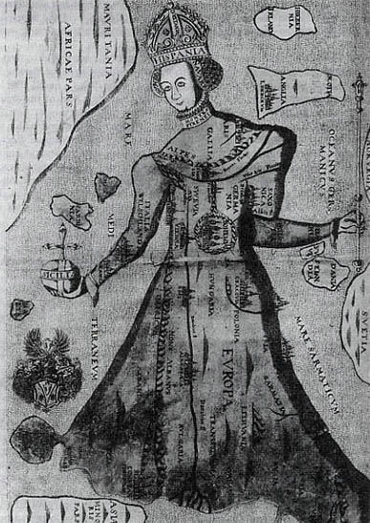

Sponsored by European Studies, the Charles Center and the Wendy and Emery Reves Center for
International Studies

Friday, April 13

Keynote Address: 4:30 pm, Washington 201

"From Boycotting Beer to Building Bombs: Borders and Borderlands in German-Speaking Central Europe, 1890-1950"

Caitlin Murdock, Associate Professor of History, California State University, Long Beach.

.

The European Studies
program at W&M is pleased
to present this student-faculty conference.

All events are free and open to
the public.

Saturday, April 14

Student Panels
Blow Hall 333

8:30 – 9:00: BREAKFAST

9:00 - 10:30: Community Building

Daniel Velez, “Catalan Identity and the Growth of Archives and Record Keeping”

Dana McKelvey, “The Bosnian Ethno-Symbolism of Pocitelj”

Alex Cooper, “Stepping out of the Closet: Organization Q and National Identity in Bosnia and Herzegovina”

10:45 - 12:15: Europe in Crisis

Robby Culhane, “Propaganda and Recruitment in Ireland during World War I”

Sarah Kathryn Atkinson, “Belarus and the Fallout from Chernobyl”

Madeleine Aggeler, “Media and Rhetoric in the Kosovo Conflict”

12:30 - 1:30: LUNCH and CLOSING REMARKS

