Guide to Completing the

Professional/Professional Faculty Performance Evaluation Form

**Determine Performance Rating:**

To assign the performance rating in a consistent manner for all professional/professional faculty, you must clearly understand the University’s rating system. Explaining the rating method to your employees prior to discussing individual ratings will allow them to understand their results in an appropriate context.

The W&M rating system in the PPF Evaluation form is below. You should understand, and be able to explain, how you determined the overall rating for the performance you are reviewing:

5 - Exceptional Performer: Employee exceeds expectations by stepping well beyond the scope of his or her position description to deliver real change to the department or unit. The individual is an exceptional employee who achieves an unusually high level of performance relative to all assignments and objectives. **The expectation is that this rating should reflect performance in the top 5% of all performers**.

4 – Advanced Performer: The employee is a critical member of the team with performance that is consistently above established expectations. The employee seeks improvement of self, office practices, team, and/or department. The individual goes above and beyond what is expected to contribute to the success of the department or unit. **The expectation is that this rating should be given to staff members who are in the top 15% of all performers.**

3 – Solid Performer: The employee fully meets the established job expectations and is a reliable and solid performer. The employee generally performs well and requires little additional guidance. The individual demonstrates initiative to meet goals and objectives of the position. The expectation is that most staff should be in this category unless they are newly hired or have new responsibilities.

2 – Developing Performer: The employee meets some of the job expectations, but not all. The individual requires support and direction to complete assignments. The employee generally performs at a minimum level and improvement is needed to fully meet expectations. This rating may be given to a new employee who has yet to learn or master a specific skill. In this latter case, the rating is a reflection of the employee’s time in the position.

1 – Under Performer: The employee’s performance generally fails to meet the established expectations or requires frequent supervision and/or the redoing of work. The individual is not performing at the level expected for employees doing this type of work. Unacceptable job performance is due to the employee’s lack of knowledge, skill or effort.

**Section 1: Performance Assessment**

**Part A: Core Competencies:** The 5 core competencies are vital to the success of all professional members at W&M. The form provides a comment section for each competency followed by a Rating section with choices ranging from 5 through 1.

**Note**: comments should be more detailed for ratings of Under-Performer (1) or Exceptional Performer (5).

An example of one of the Core Competencies follows:

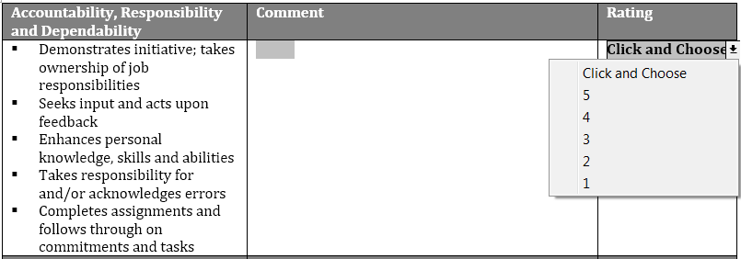

**Part B: Supervisor Competencies:** The two competencies are vital to the success of all individuals who supervise staff and/or students. Please rate the performance with respect to the supervisory competencies.

**Note:** comments should be more detailed for ratings of Under-Performer (1) or Exceptional Performer (5).

If this employee is not a supervisor, do not complete these competencies and check the box next to Not Applicable.

An example of one of the Supervisor Competencies follows:

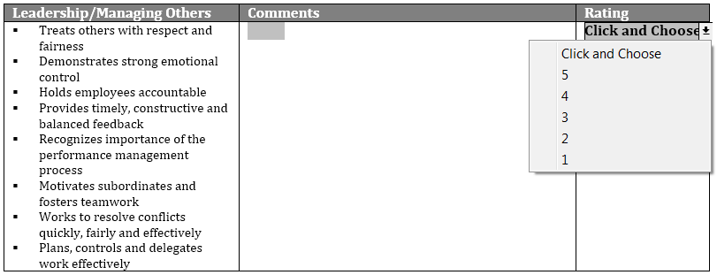

**Calculating Average Overall Performance Rating for Part A & B:**

Add the rating for each individual core competency in Part A:

Rating for Accountability, Responsibility & Dependability;

Rating for Relationship Building;

Rating for Communication;

Rating for Institutional Values;

Rating for Problem Solving/Decision Making;

If applicable, add the rating for both supervisor competencies in Part B:

Rating for Leadership/Managing Others;

Rating for Coaching and Developing;

Total all ratings, divide by the number of ratings to calculate the Average Overall Performance Rating for Part A & B. Enter that rating on the form.



**Part C: Core Job Responsibilities & Achievement of Goals:** List and rate the professional member’s performance goals and/or specific job responsibilities for the prior year performance plan. If there are more than 4 goals or objectives, attach additional pages.

Note that comments should be more detailed for ratings of Under-Performer (1) or Exceptional Performer (5).

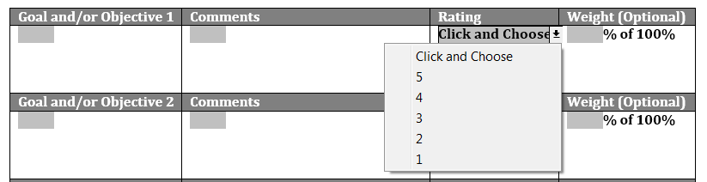

Assigning a Weight to a Goal and/or Objective (optional): This is an effective way to communicate the relative importance of a goal and/or objective. By knowing the relative weight an employee can prioritize their work and efforts.

Total all ratings, divide by the number of ratings to calculate the Average Overall Performance Rating for Part C: Enter that rating on the form.



**Section II: Overall Performance Appraisal Rating**

The Average Performance Rating for Parts A & B are added to the Average Performance Rating for Part C, then divided by 2 to calculate the Overall Performance Rating. Enter that rating on the form.

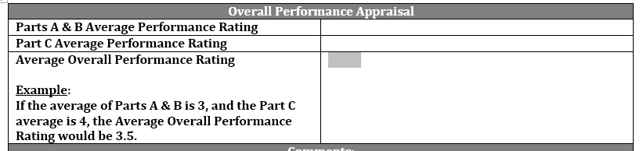

A Comment section is provided on the form.

**Section III. Training and Development Opportunities**

A section is provided for identifying any professional training and/or development opportunities you would like the employee to complete during the upcoming performance review period.

**Section IV: Employee Comments**

A section is provided for the employee’s comments.

**Signatures and Verifications**

The employee and supervisor will sign and date this form. The supervisor will provide the evaluation documentation to the reviewer for review and approval.