Guide to Completing the

Professional/Professional Faculty Performance Goals Form

At the beginning of the performance year, the supervisor, with input from the employee, will develop a performance plan. The plan includes specific annual goals or objectives and professional training and development goals for the employee.

The Performance Goals form provides up to five sections for the plan to include an optional Weight, a Target Completion Date, Mid-Year Check In, and comments.

An example of one of the Performance Goal sections follows:

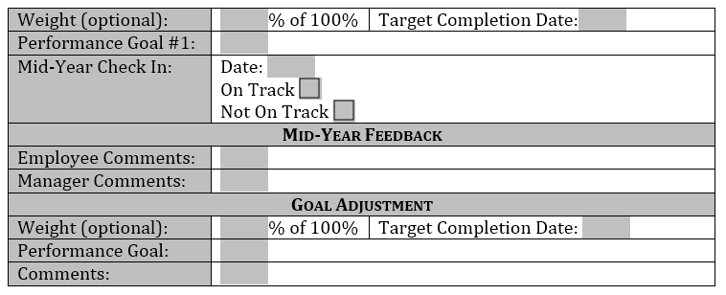

**Assigning a Weight to a Goal and/or Objective (optional):** This is an effective way to communicate the relative importance of a goal and/or objective. By knowing the relative weight an employee can prioritize their work and efforts.

**General Comments:**

A section is provided for the general comments.

**Signatures and Verifications:**

The employee and supervisor will sign and date this form. The supervisor will provide the evaluation documentation to the reviewer for review and approval.